Information Security COMP-421-B

Name & Rollnum: Mahnoor Khalid

241555407

Assignment - 1

Task 1 Commands of Link 1:  
<https://www.offsec.com/metasploit-unleashed/port-scanning/>

**Nmap & db_nmap:**

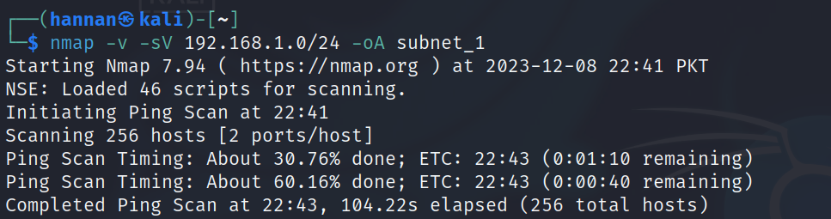

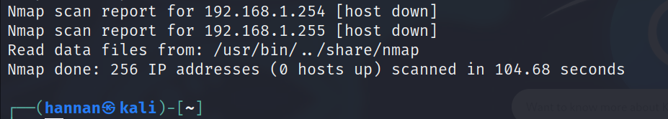

**Port Scanning:**

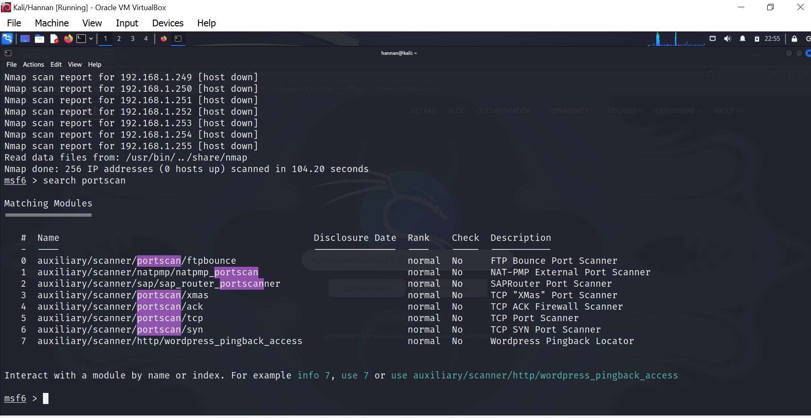

**Cat Subnet:**  
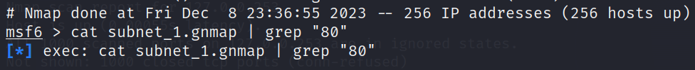

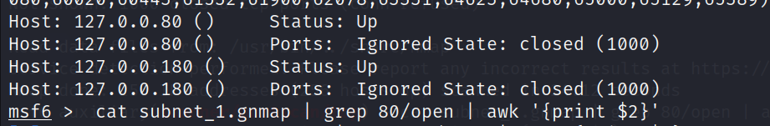

**SYN Scan:**

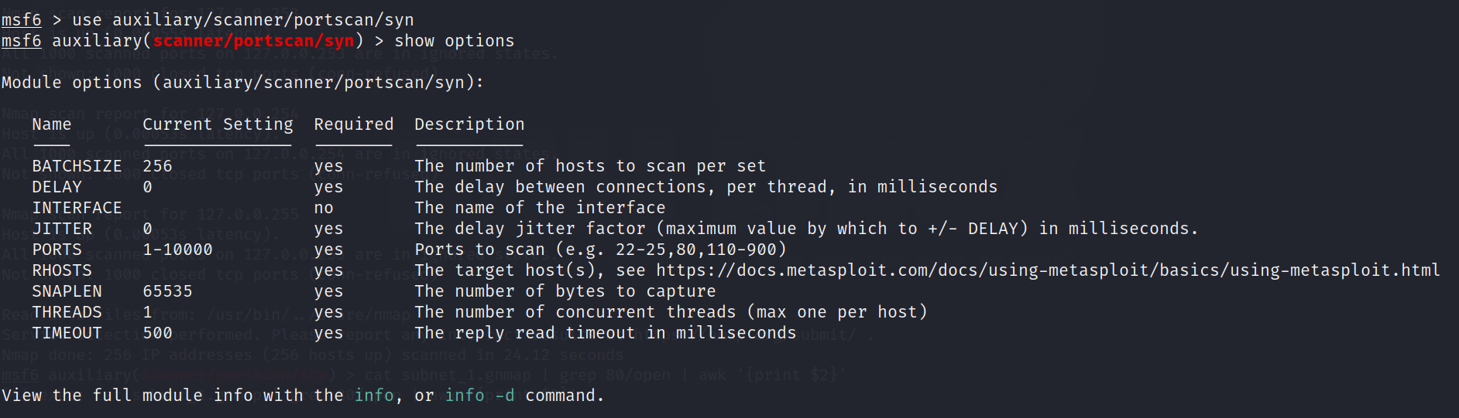

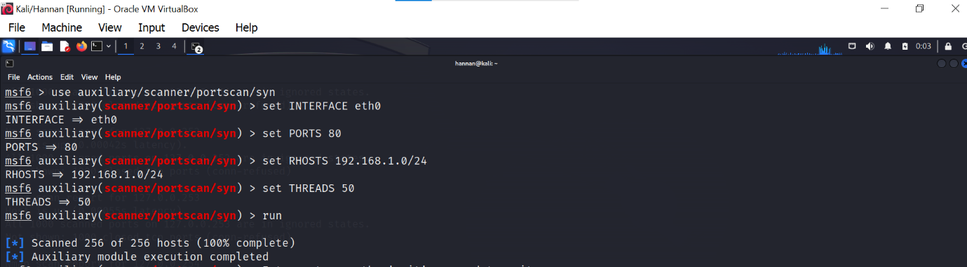

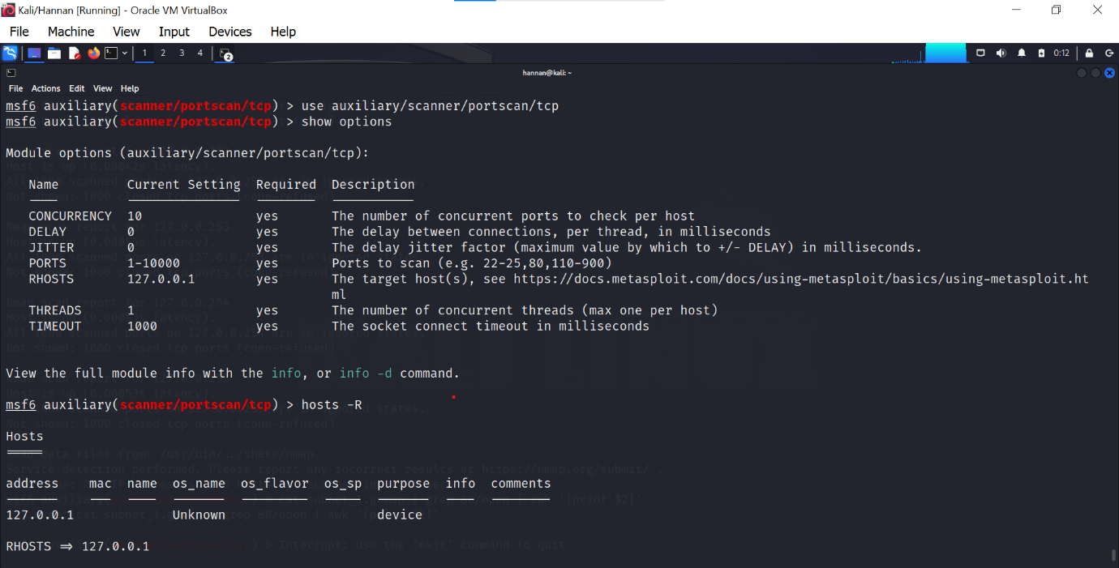

**Run Command:**

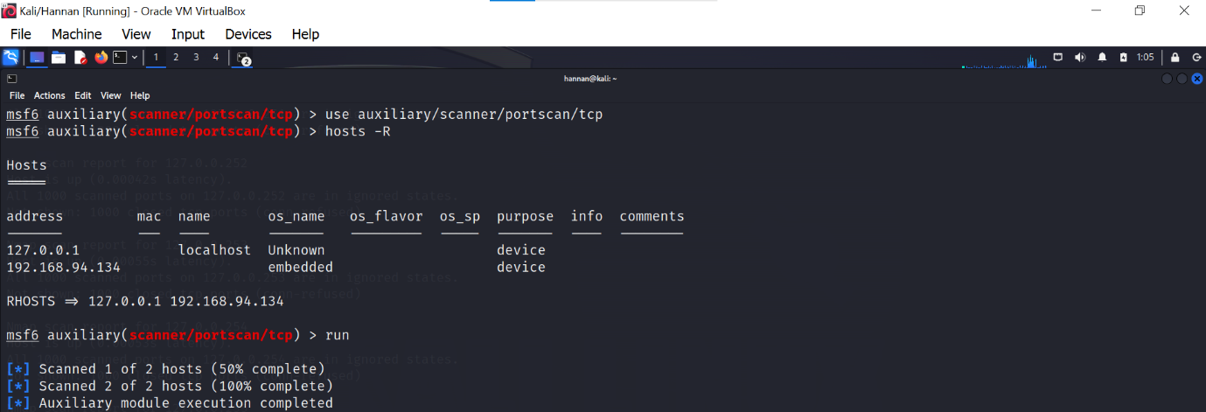

**SMB Version Scanning:**

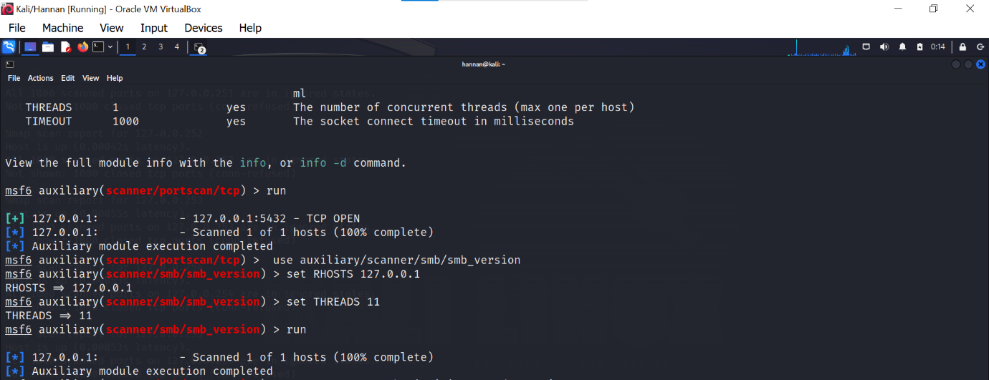

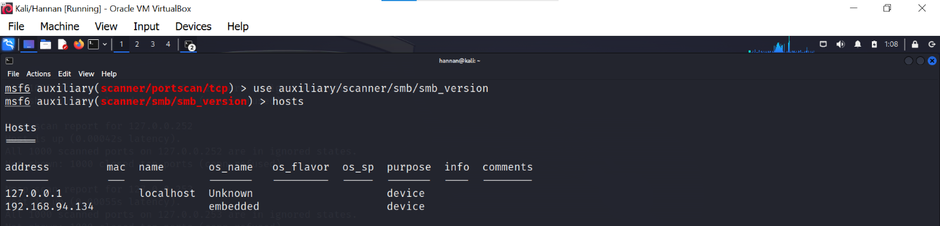

**IDLE Scanning:**

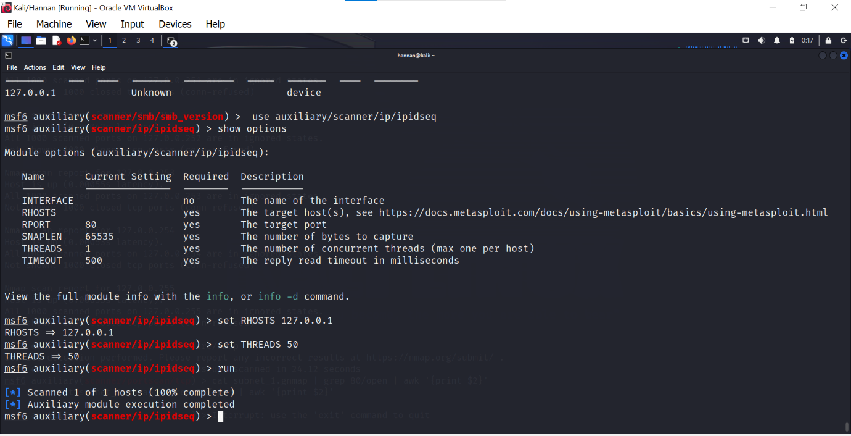

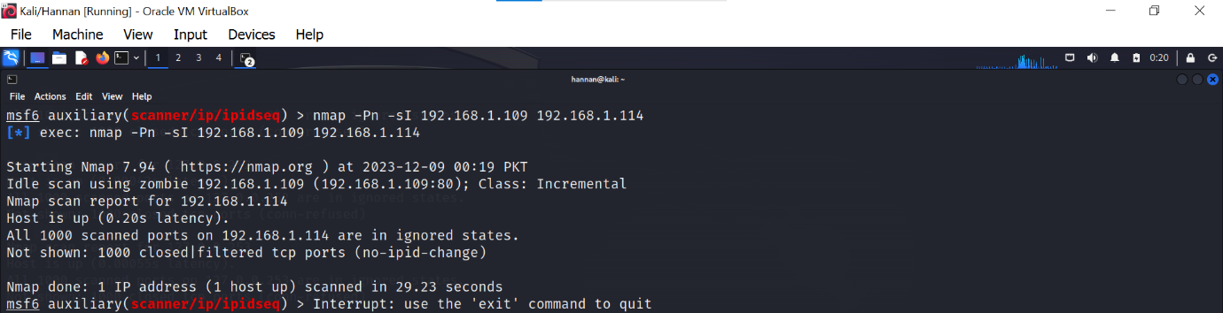

**Task 2 Commands of Link 2**

<https://www.cm-alliance.com/cybersecurity-blog/using-metasploit-and-nmap-to-scan-for-vulnerabilities>

**Using Metasploit and Nmap to scan for vulnerabilities:**

use auxiliary/scanner/portscan/tcp

set PORTS 22,25,80,110,21

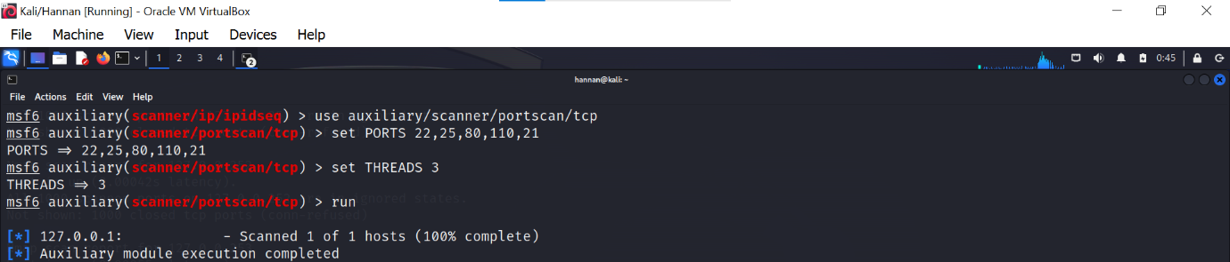

**Nmap with Metasploit for a more detailed scan on client machine:**

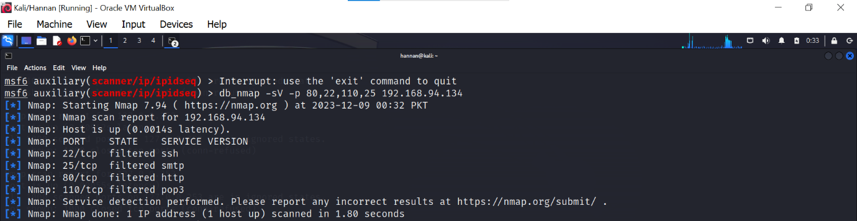

## **Scanning for vulnerabilities with Nmap and Metasploit:**

## C:\Users\Hi\Desktop\scanning vuln with ms and nmap.png